|  |
| --- |
| **Saveetha** **University Online ID Card Creation Platform** |
| A CAPSTONE PROJECT  Submitted By |
|  |
| K N Bhuvaneswar Reddy(192210576)  **&**  K Kalyan (192211311) |
| In Partial Fulfillment for the completion of the course |
| PROGRAMMING IN JAVA for Web Applications  **(CSA0910)**  SEP 2024 |
|  |
| SAVEETHA INSTITUTE OF MEDICAL AND TECHNICAL SCIENCES  CHENNAI - 602105  TAMIL NADU, INDIA |



# **BONAFIDE CERTIFICATE**

This is to certify that the project report entitled Saveetha **University Online ID Card Creation Platform** submitted by K Bhuvaneswar Reddy (192210576) & K Kalyan (192211311), to Saveetha School of Engineering, Saveetha Institute of Medical and Technical Sciences, Chennai, is a record of bonafide work carried out by him/her under my guidance. The project fulfills the requirements as per the regulations of this institution and in my appraisal meets the required standards for submission.

**COURSE FACULTY**

*Dr. A Ganesh Ramachandran*

*Department of Deep Cyber Security.*

*Saveetha School of Engineering,*

*SIMATS, Chennai - 602105*

# **ACKNOWLEDGEMENT**

This project work would not have been possible without the contribution of many people. It gives me immense pleasure to express my profound gratitude to our Honorable Chancellor **Dr. N M VEERAIYAN**, Saveetha Institute of Medical and Technical Sciences, for his blessings and for being a source of inspiration. I sincerely thank our Director of Academics **Dr. DEEPAK NALLASWAMY,** SIMATS, for his visionary thoughts and support. I am indebted to extend my gratitude to our Director **Dr. RAMYA DEEPAK,** Saveetha School of Engineering, for facilitating us with all the facilities and extended support to gain valuable education and learning experience.

I register my special thanks to **Dr. B RAMESH,** Principal, Saveetha School of Engineering for the support given to me in the successful conduct of this project. I wish to express my sincere gratitude to my Course faculty **Dr A Ganesh Ramachandran**, for his inspiring guidance, personal involvement and constant encouragement during the entire course of this work.

I am grateful to Project Coordinators, Review Panel External and Internal Members and the entire faculty of the Department of Design, for their constructive criticisms and valuable suggestions which have been a rich source to improve the quality of this work.

**INDEX**

BONAFIDE CERTIFICATE 1

ACKNOWLEDGEMENT 2

1. ABSTRACT 4

2. INTRODUCTION 5

3. ARCHITECTURE DIAGRAM 7

4. FLOWCHART 8

5. CLASS DIAGRAM 9

6. CODE IMPLEMENTATION 10

6.1 JAVA CODE 10

6.2 HTML CODE 11

6.3 CSS CODE 12

7. OUTPUT SCREENSHOT 15

8. CONCLUSION………. ………..21

# **ABSTRACT**

This capstone project focuses on the development of a smart ID card generation system tailored for Saveetha University. The project involves creating a dynamic and responsive web application that allows users to generate personalized ID cards with ease. The system architecture integrates HTML for the frontend, CSS for enhanced styling, and JavaScript for handling dynamic data input and interactions. The application supports features such as real-time data entry, logo integration via an online URL, and a download option for the ID card in PDF format. This project showcases the effective use of web technologies to create a user-friendly and efficient ID card generation system, demonstrating the practical application of front-end and back-end development skills.

# **INTRODUCTION**

In the modern digital era, universities are increasingly adopting technological solutions to enhance the efficiency and security of their operations. One such vital area is the generation and management of student and staff identification (ID) cards. Traditionally, ID card issuance has been a manual, time-consuming process, often requiring significant administrative resources. With the increasing number of students and staff members, the need for a more streamlined, automated system has become paramount. This project, titled "Saveetha University Smart ID Card Generation System," aims to address these challenges by providing a web-based solution that simplifies and automates the ID card creation process.

**Importance of ID Cards in Educational Institutions**

ID cards serve as essential tools in educational institutions, playing a critical role in ensuring security, facilitating access to campus facilities, and identifying members of the university community. In addition to providing proof of identity, ID cards often contain barcodes or QR codes that can be scanned for attendance tracking, library access, and even cashless transactions within the campus. Given their importance, it is crucial that ID cards are generated with accuracy, contain up-to-date information, and are resistant to tampering.

**Project Objectives and Scope**

The primary objective of this project is to develop a smart, web-based ID card generation system specifically tailored for Saveetha University. The system is designed to be user-friendly, allowing administrators and authorized personnel to generate ID cards efficiently without the need for extensive technical knowledge. The scope of the project includes developing a responsive frontend interface using HTML and CSS, ensuring that the application can be accessed and used across various devices, including desktops, tablets, and smartphones.

A significant feature of the system is its dynamic data input capability. Unlike traditional systems where card details are hardcoded, this system allows users to input data in real-time, making the process more flexible and reducing the chances of errors. The integration of JavaScript enables the system to handle dynamic content and interactions, such as uploading photos, selecting templates, and previewing the ID card before finalization.

In addition to real-time data input, the system also supports the incorporation of Saveetha University's official logo via an online URL, ensuring that each ID card adheres to the institution's branding guidelines. Once the ID card is generated, the system offers an option to download it as a PDF file, making it easy for users to print or store the card digitally.

**Technological Considerations**

The development of the Saveetha University Smart ID Card Generation System leverages several modern web technologies. The backend, though not the primary focus of this project, could be extended to include a database for storing student and staff information securely. This would allow for easy retrieval and updating of records, further enhancing the system's functionality.

The frontend, built using HTML, CSS, and JavaScript, is designed to be intuitive and responsive. HTML provides the structural framework of the application, while CSS is used to create an aesthetically pleasing and consistent design. JavaScript, a versatile scripting language, is employed to add interactivity to the system, enabling features like form validation, data binding, and real-time previews.

One of the core features of this project is its emphasis on mobile responsiveness. In today's world, users expect to be able to access applications from various devices. By ensuring that the ID card generation system is fully responsive, the project ensures that administrators can perform their tasks on-the-go, without being tied to a desktop computer. This flexibility is particularly important in a university setting, where staff members may need to generate or access ID cards from different locations on campus.

# **3. ARCHITECTURE DIAGRAM**

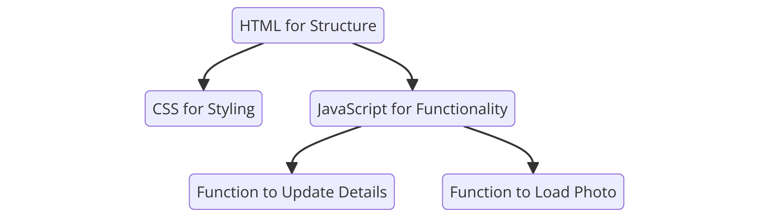

Figure 3.1 : Architecture Diagram

The architecture diagram of the currency conversion application illustrates the various components and their interactions within the system. This modular architecture ensures scalability, maintainability, and efficient performance.

**Purpose:** Shows the relationship between the structural, styling, and functional elements of your code.

Components:

**HTML for Structure:** Defines the skeleton of the web page (header, photo container, details, footer).

**CSS for Styling:** Handles the visual presentation, including layout, colors, and styles for the card and buttons.

**JavaScript for Functionality:** Contains the interactive features such as the loadPhoto() for uploading a photo and updateDetails() to update the ID card details.

**Use Case:** Illustrates how HTML, CSS, and JavaScript work together to build the ID card system.

# **4. FLOWCHART**

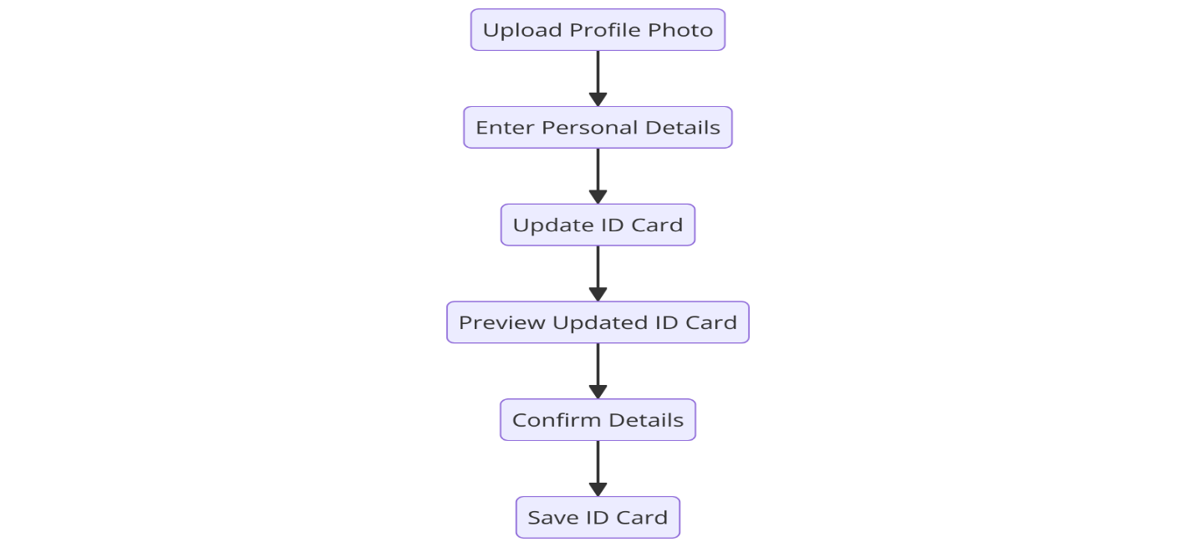

Figure 4.1 : Flowchart

The flowchart for the currency conversion application depicts the step-by-step process from user input to the final conversion result.

**Purpose:** Visualizes the user interaction flow in the ID card system.

**Main Steps:**

**Upload Profile Photo:** User uploads their image.

**Enter Personal Details:** User enters information like name, ID, department, and year.

**Update ID Card:** The system updates the ID card display with the new details.

**Preview Updated ID Card:** User previews the updated ID card with the entered details.

**Confirm Details:** User confirms if all the entered details are correct.

**Save ID Card:** After confirmation, the ID card is saved.

**Use Case:** Guides the user through creating an ID card from start to finish.

# **5. CLASS DIAGRAM**

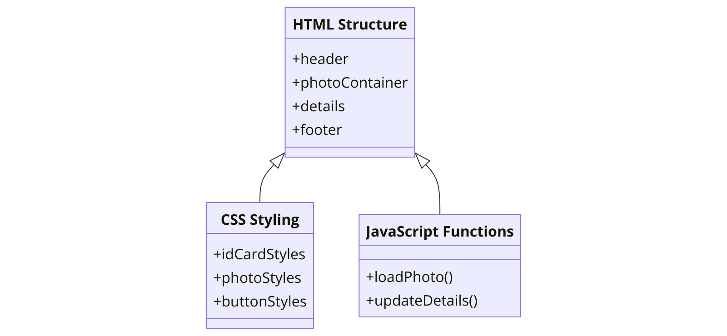

Figure 5.1: Class Diagram

The class diagram specifies the structure of the system by showing the system's classes, their attributes, methods, and the relationships among the objects.

**Purpose:** Depicts the structure and interactions between different parts of your system.

**Classes:**

**HTML Structure:** Represents the HTML elements like header, photo container, and details section.

**CSS Styling:** Manages styles for ID card elements such as idCardStyles, photoStyles, and buttonStyles.

**JavaScript Functions:** Encapsulates the main functions such as loadPhoto() for image uploading and updateDetails() for updating user info.

# **6. CODE IMPLEMENTATION**

## **6.1 JAVA CODE**

function loadPhoto(event) {

const photo = document.getElementById('profile-photo');

photo.src = URL.createObjectURL(event.target.files[0]);

}

function updateDetails() {

const name = document.getElementById('input-name').value;

const id = document.getElementById('input-id').value;

const department = document.getElementById('input-department').value;

const year = document.getElementById('input-year').value;

document.getElementById('name').textContent = name;

document.getElementById('id').textContent = id;

document.getElementById('department').textContent = department;

document.getElementById('year').textContent = year;

}

## **6.2 HTML CODE**

<!DOCTYPE html>

<html lang="en">

<head>

<meta charset="UTF-8">

<meta name="viewport" content="width=device-width, initial-scale=1.0">

<title>Saveetha ID Card</title>

<link rel="stylesheet" href="styles.css">

</head>

<body>

<div class="id-card">

<div class="header">

<h1>Saveetha University</h1>

</div>

<div class="photo-container">

<img id="profile-photo" src="https://via.placeholder.com/150" alt="Profile Photo">

</div>

<div class="details">

<p><strong>Name:</strong> <span id="name"></span></p>

<p><strong>ID:</strong> <span id="id"></span></p>

<p><strong>Department:</strong> <span id="department"></span></p>

<p><strong>Year:</strong> <span id="year"></span></p>

</div>

<div class="footer">

<p>&copy; 2024 Saveetha University</p>

</div>

</div>

<input type="file" id="upload-photo" accept="image/*" onchange="loadPhoto(event)">

<div class="form-container">

<input type="text" id="input-name" placeholder="Enter Name">

<input type="text" id="input-id" placeholder="Enter ID">

<input type="text" id="input-department" placeholder="Enter Department">

<input type="text" id="input-year" placeholder="Enter Year">

<button onclick="updateDetails ()">Update ID Card</button>

</div>

<script src="script.js"></script>

</body>

</html>

## **6.3 CSS CODE**

body {

display: flex;

flex-direction: column;

align-items: center;

justify-content: center;

height: 100vh;

margin: 0;

background-color: #e6e6fa; /* Light purple background */

font-family: 'Arial', sans-serif;

}

.id-card {

background-color: white;

border-radius: 15px;

box-shadow: 0 4px 8px rgba(0, 0, 0, 0.2);

width: 300px;

padding: 20px;

text-align: center;

transition: transform 0.3s;

margin-bottom: 20px;

}

.id-card:hover {

transform: scale(1.05);

}

.header h1 {

font-size: 1.5em;

color: #4b0082; /* Dark purple */

margin-bottom: 20px;

}

.photo-container {

margin-bottom: 20px;

}

.photo-container img {

width: 100px;

height: 100px;

border-radius: 50%;

border: 2px solid #4b0082;

object-fit: cover;

}

.details p {

font-size: 1em;

color: #333;

margin: 5px 0;

}

.footer {

margin-top: 20px;

font-size: 0.8em;

color: #4b0082;

}

#upload-photo {

margin-top: 20px;

padding: 10px;

font-size: 0.9em;

border: none;

border-radius: 5px;

background-color: #4b0082;

color: white;

cursor: pointer;

transition: background-color 0.3s;

}

#upload-photo:hover {

background-color: #3a0061;

}

.form-container {

display: flex;

flex-direction: column;

align-items: center;

}

.form-container input {

margin: 5px 0;

padding: 8px;

border-radius: 5px;

border: 1px solid #4b0082;

width: 280px;

}

.form-container button {

margin-top: 10px;

padding: 10px;

font-size: 0.9em;

border: none;

border-radius: 5px;

background-color: #4b0082;

color: white;

cursor: pointer;

transition: background-color 0.3s;

}

.form-container button:hover {

background-color: #3a0061;

}

# **7. OUTPUT SCREENSHOT**

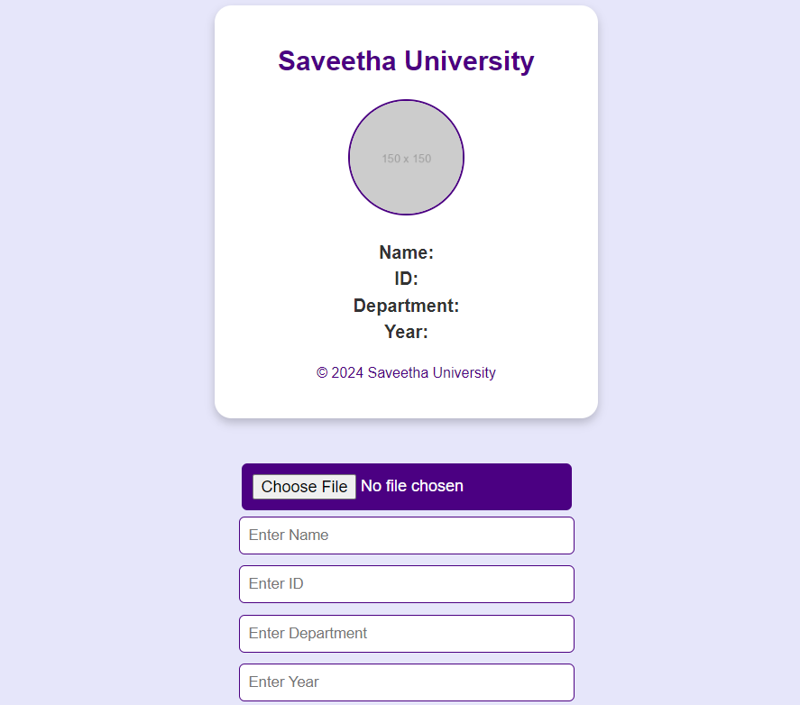

Figure 7.1: ID Card Before filling the Details

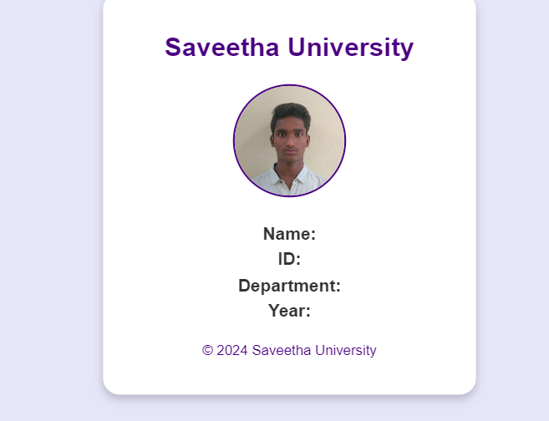

Figure 7.2: ID Card After Uploading Image

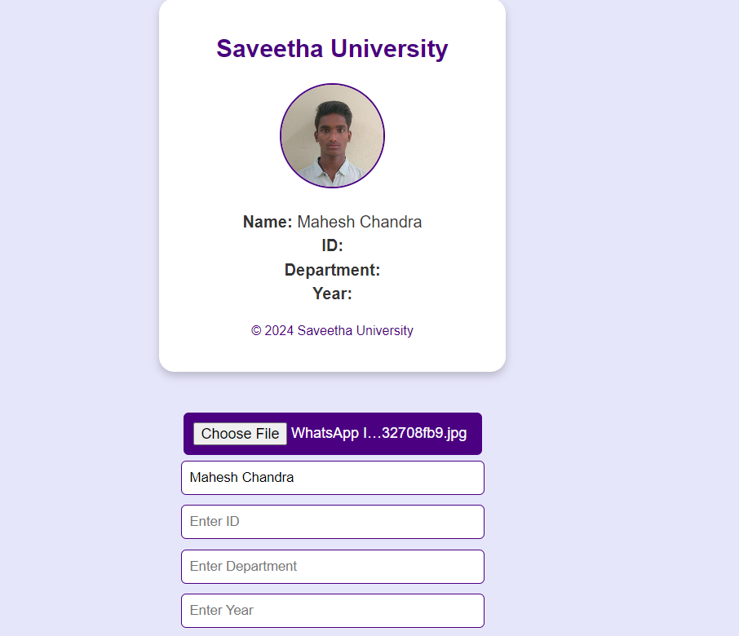

Figure 7.3: ID After entering Name

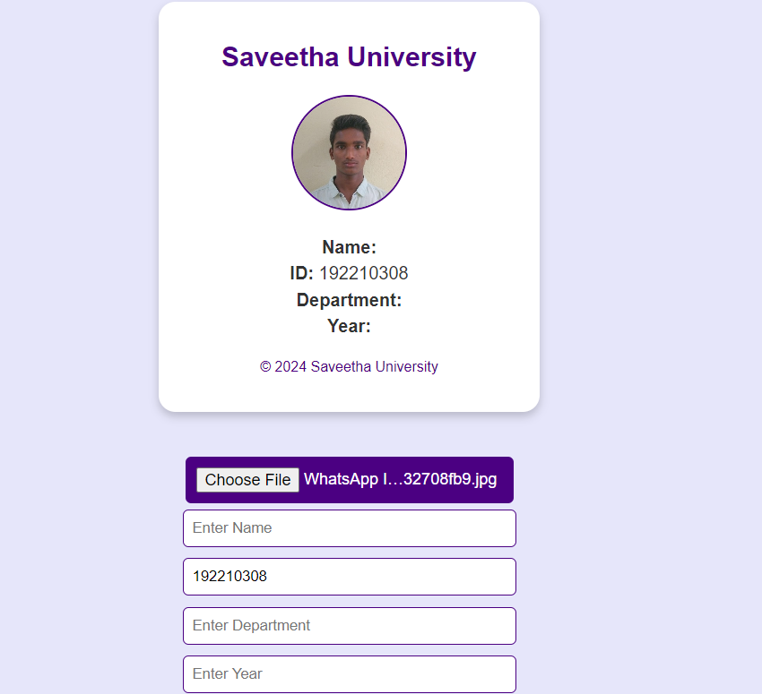

Figure 7.4: ID Card After Entering ID NO

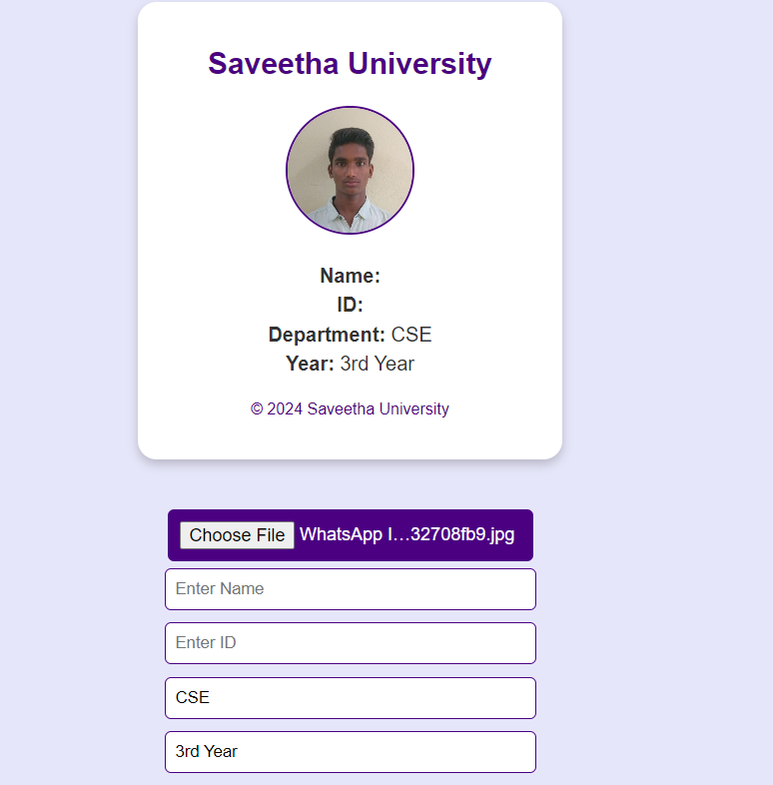

Figure 7.5: After filling Dep & Year details of Person

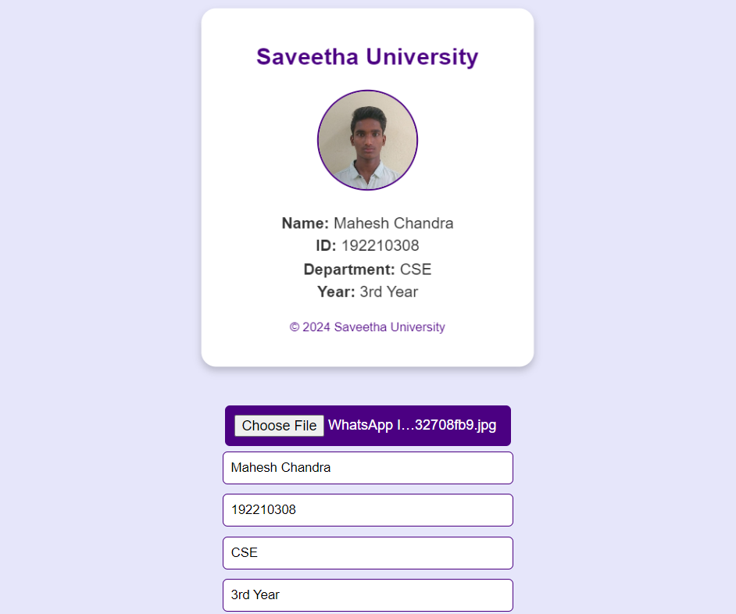

Figure 7.6: Final Output

# **8. CONCLUSION**

The ID card system project effectively demonstrates the integration of key web technologies—HTML for structure, CSS for styling, and JavaScript for functionality. The flowchart provides a clear visualization of the step-by-step user interaction, making it easy to understand how data flows through the system. The architecture diagram offers a high-level overview of the relationship between different components, emphasizing how structure, design, and logic come together to form a cohesive application. Meanwhile, the class diagram helps to clarify the connections between different elements, such as how JavaScript functions interact with the HTML and CSS to enable dynamic updates. Together, these diagrams showcase a well-rounded and scalable system, ideal for creating user-friendly, interactive web applications. This holistic approach ensures modularity, maintainability, and ease of further enhancements in the future.

# **9. REFERENCES**

1. Quarmby, Ben (January 31, 2003). "The case for national identification cards". 2003 Duke L. & Tech. Rev. 0002. Duke University: E1. PMID 15709289.
2. "A brief history of the passport", The Guardian, November 17, 2006.
3. Hall, Roger, Gordon Dodds, Stanley Triggs (1993). The World of William Notman. David R. Godine. pp. 46, 47. ISBN 9780879239398. Retrieved 2015-12-31.
4. Doward, Jamie (May 29, 2005). "ID cards to cost £300 per person". The Guardian. London. Retrieved 2010-05-05.
5. "Combien coûte une Carte Nationale d'Identité ?". Vos Démarches. French Government. Retrieved 2019-08-14.
6. Zaba, Christina (May 30, 2005). "When the eyes don't have it". New Statesman. Archived from the original on 2008-05-16.
7. Jump up to:**a** [**b**](https://en.wikipedia.org/wiki/Identity_document#cite_ref-diariandorra_16-1) Poy, Ricard (June 7, 2017). "Cal un DNI andorrà". Diari d'Andorra (in Catalan).
8. "NATIONAL ID CARD BEING CONSIDERED BY GOVERNMENT | the Tribune".
9. "National IDs Around the World – Interactive map | World Privacy Forum".
10. "Politiet: Nye pass og nasjonale ID-kort kommer 1. April 2018". January 5, 2017.